Optimisation of MLP and CNN Models for MNIST Handwritten Digits Classification

1. Introduction
The MNIST (Modified National Institute of Standards and Technology) dataset, is a widely used benchmark for evaluating machine learning models. It contains 70,000 grayscale images of handwritten digits under 10 categories (0 to 9) with 60000 training and 10000 test samples. The classification task is inherently suitable for neural networks due to the dataset’s structured input (28 × 28 images) and categorical output (10 classes). This report explores three tasks:
- Task 1: Implementation and comparison of baseline and improved Multilayer Perceptron (MLPs).
- Task 2: Development and comparison of baseline and improved Convolutional Neural Networks (CNNs).
- Task 3: Evaluation of two different learning rates and two different optimisers in the performance of improved CNN model.
Each task includes description of the model architecture, hyperparameter settings, and analysis of the model performance.

2. Data Preprocessing
Before training the models, the MNIST dataset need to undergo different preprocessing steps to ensure that the data is in a suitable format for both the MLP and CNN architectures. The dataset contains 28×28 grayscale images of handwritten digits along with their corresponding labels.
The first preprocessing step involves normalizing the pixel values to the range 0–1 by dividing each pixel by 255. This scaling standardizes the input features, stabilizes training, and facilitates faster convergence of the optimization algorithm.
For the MLP model, each image is then flattened into a one-dimensional vector of length 784, obtained by multiplying the width and height of the image (28 × 28). Flattening converts the spatial 2D structure of the image into a linear format compatible with fully connected layers. In contrast, the CNN model retains the original 2D shape of the images, as convolutional layers are designed to exploit spatial relationships in the data.
Finally, the labels, which are originally integers from 0 to 9, are transformed into one-hot encoded vectors of length 10. One-hot encoding allows the models to output class probabilities using Softmax and compute the categorical cross-entropy loss for multi-class classification tasks.

3. MLP Models for Digits Classification (Task 1)

3.1 Baseline MLP – Architecture and Settings
The baseline Multilayer Perceptron (MLP) used in this study follows a minimal architecture designed to establish a reference point for performance evaluation.

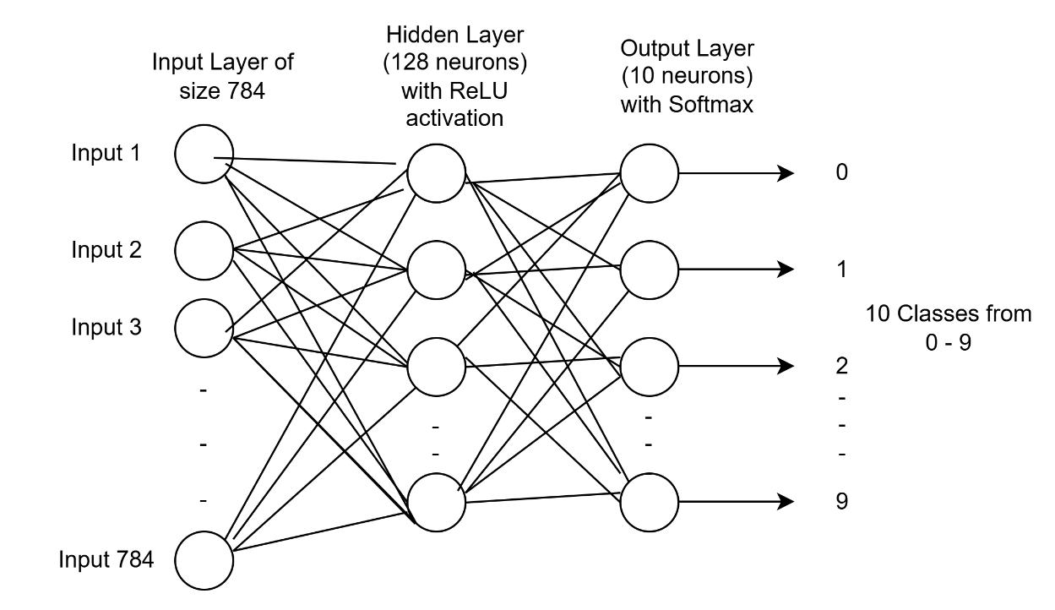

Architecture Diagram of Baseline MLP Model

The input layer accepts a one-dimensional vector of length 784 which is a flattened 28 x 28 grayscale image. The model consists of a single hidden layer and an output layer. The hidden layer is a Dense layer with 128 neurons and uses the ReLU activation function, allowing the model to learn non-linear patterns from the input data. The output layer is a Dense layer with 10 neurons, corresponding to the ten-digit classes, and applies a softmax activation function to produce a probability distribution over the classes.
The model is trained using the Adam optimizer with a default learning rate of 0.001, which provides adaptive learning rates for efficient convergence. The categorical cross-entropy loss function is used to measure the difference between predicted class probabilities and the true one-hot encoded labels. Training is performed over 10 epochs with a batch size of 32, and 10% of the training data is reserved for validation to monitor the model’s performance on unseen data during training.
Overall, this architecture serves as a simple yet effective baseline for MNIST classification. The inclusion of a hidden layer with ReLU activation enables the network to capture non-linear relationships, while the softmax output layer provides probabilistic predictions for the ten classes.

Model Architecture
Component | Description
Input Layer | Flattened 28 x 28 grayscale image to 1D vector of size 784
Hidden Layer | 1 x Dense Layer (128 neurons, ReLU)
Output Layer | Dense (10 neurons, Softmax)

Hyperparameters
Hyperparameter | Value
Optimiser | Adam
Learning Rate | 0.001 (default)
Loss Function | Categorical Crossentropy
Epochs | 10
Batch Size | 32
Validation_size | 0.1

Total Trainable Parameters
- Input Layer = 784
- Fully connected Layer with 128 neurons
- Weights = 784 × 128 = 100,352
- Biases = 128
Total = 100,352 + 128 = 100,480
- Output layer with 10 neurons
- Weights = 128 × 10 = 1,280
- Biases for output layer = 10
Total for output layer = 1,280 + 10 = 1,290

Total trainable parameters = 100,480 + 1,290 = 101,770

3.1.1 Training and Testing Results
The plots of training/validation accuracy and loss, along with the test accuracy and loss results, are presented below.
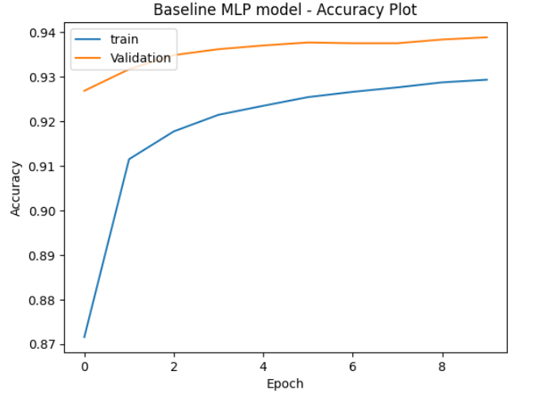
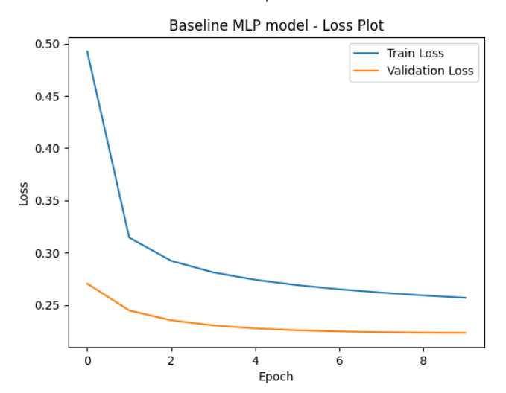
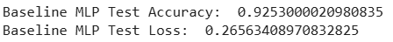
The Baseline MLP model was trained for 10 epochs. Training started with an accuracy of 80.30% and a relatively high loss of 0.7572. Over the epochs, the model improved steadily, reaching 93.07% accuracy with a training loss of 0.2552.
Validation performance followed a similar trend, beginning at 92.68% accuracy (loss = 0.2704) and gradually improving to 93.88% accuracy with a validation loss of 0.2232.
On the test set, the Baseline MLP achieved a final accuracy of 92.53% and a loss of 0.2656. These results indicate that while the model generalizes well, the accuracy and loss can be improved with better models.

3.2 Improved MLP – Architecture and Settings

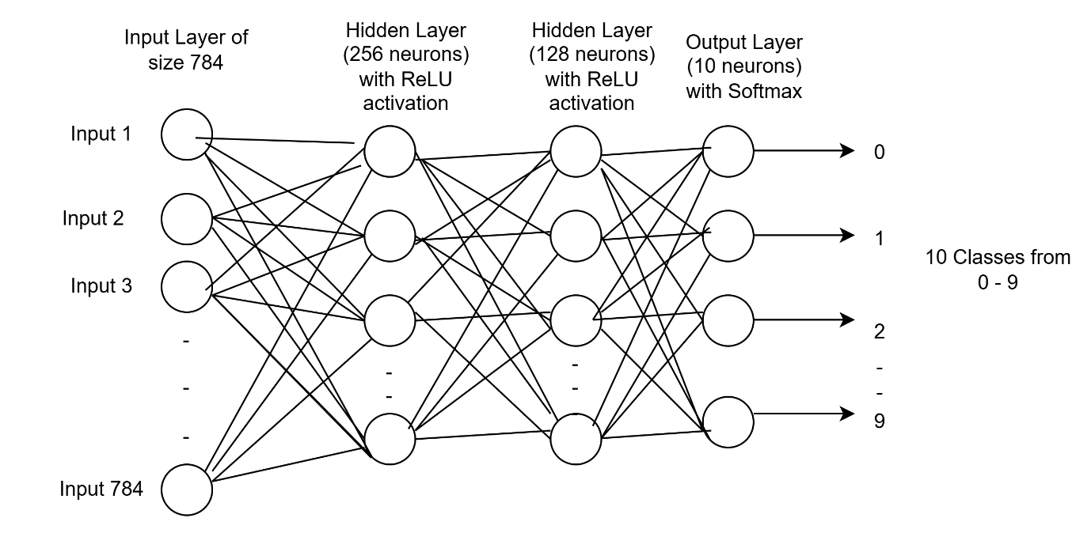
Architecture Diagram of Improved MLP Model

The improved Multi-Layer Perceptron (MLP) model is an enhanced version of the baseline, designed to better capture the complex patterns in the MNIST dataset. Similar to baseline model, each input image of size 28×28 is first flattened into a one-dimensional vector of length 784.
The network architecture consists of two hidden layers. The first hidden layer contains 256 neurons with ReLU activation, enabling the model to learn non-linear features from the input. The second hidden layer contains 128 neurons, also with ReLU activation, which allows the network to extract more refined and hierarchical representations before passing the information to the output layer. The output layer is a Dense layer with 10 neurons corresponding to the ten-digit classes, using a softmax activation to generate a probability distribution across the classes.
The model is trained using the Adam optimizer with a default learning rate of 0.001 and uses categorical cross-entropy as the loss function. Training is performed for 10 epochs with a batch size of 32, and 10% of the training data is reserved for validation to monitor the model’s performance on unseen data.
By adding an additional hidden layer with more neurons, this improved MLP model is capable of learning more complex non-linear patterns, which is expected to improve classification performance compared to the baseline model.

Model Architecture
Component | Description
Input Layer | Flattened 28 x 28 grayscale image to 1D vector of size 784
Hidden Layer 1 | Dense Layer (256 neurons with ReLU activation)
Hidden Layer 2 | Dense Layer (128 neurons with ReLU activation)
Output Layer | Dense (10 neurons, Softmax)

Hyperparameters
Hyperparameter | Value
Optimiser | Adam
Learning Rate | 0.001 (default)
Loss Function | Categorical Crossentropy
Epochs | 10
Batch Size | 32
Validation_size | 0.1

Total Trainable Parameters
- Input Layer = 784
- Hidden Layer 1 with 256 neurons
- Weights: 784 × 256 = 200,704
- Biases: 256
Total = 200,704 + 256 = 200,960
- Hidden Layer 2 with 128 neurons
- Weights: 256 × 128 = 32,768
- Biases: 128
Total = 32,768 + 128 = 32,896
- Output layer with 10 neurons
- Weights = 128 × 10 = 1,280
- Biases for output layer = 10
Total for output layer = 1,280 + 10 = 1,290

Total trainable parameters = 200,960 + 32,896 + 1,290 = 235,146

3.2.1 Training and Testing Results
The plots of training/validation accuracy and loss, along with the test accuracy and loss results, are presented below.
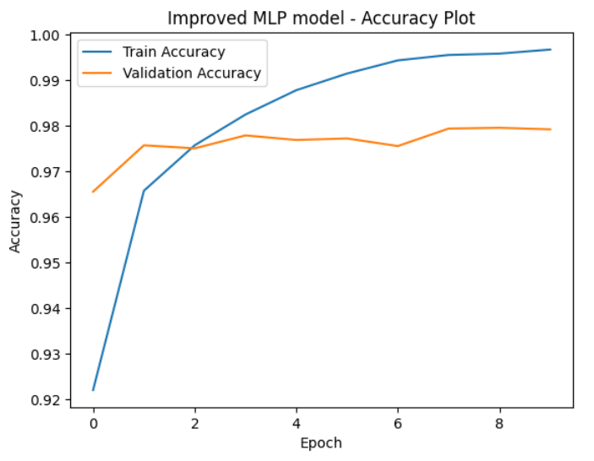
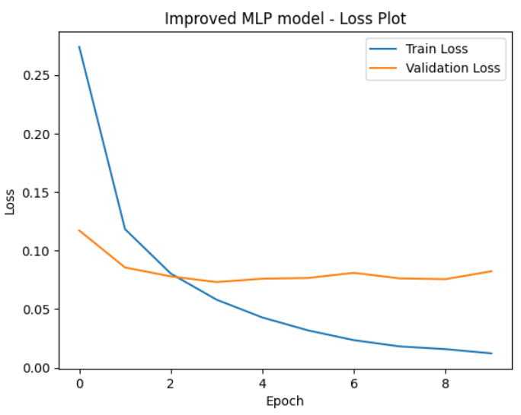

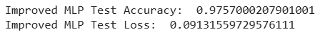

The improved MLP showed strong learning progression across 10 epochs. Training accuracy increased steadily from 87.22% in epoch 1 to 99.66% by epoch 10, while training loss reduced from 0.460 to 0.013, reflecting efficient optimization. Validation accuracy remained consistently high, reaching a peak of 97.92%, while validation loss stabilized around 0.082, indicating effective generalization with minimal overfitting.
On the test set, the improved MLP achieved a final accuracy of 97.57% and a test loss of 0.091, outperforming the baseline MLP significantly. These results highlight the model’s robustness and improved capacity to recognize digit classes with higher precision.

3.3 Comparison of Baseline MLP and Improved MLP Test Results
The table below shows the test accuracy and loss of both the models.
Model | Epochs | Batch Size | Test Accuracy | Test Loss
Baseline MLP | 10 | 32 | 92.53 % | 0.265
Improved MLP | 10 | 32 | 97.57% | 0.091

Per class accuracy comparison between baseline and Improved MLP models is provided in the below table
Class | Baseline MLP | Improved MLP
0 | 0.9806 | 0.9847
1 | 0.9824 | 0.9894
2 | 0.8934 | 0.9641
3 | 0.9040 | 0.9772
4 | 0.9308 | 0.9847
5 | 0.8834 | 0.9664
6 | 0.9478 | 0.9729
7 | 0.9407 | 0.9786
8 | 0.8881 | 0.9723
9 | 0.8920 | 0.9643

Analysis
The baseline MLP achieved a test accuracy of 92.53% with a loss of 0.265, while the improved MLP showed a significant performance boost, reaching 97.57% accuracy with a much lower loss of 0.091.
Per-class accuracy results further highlight this improvement. The improved MLP outperformed the baseline across nearly all digit classes, with the most notable gains in digits 2 (from 89.3% to 96.4%), 3 (from 90.4% to 97.7%), 5 (from 88.3% to 96.6%), and 8 (from 88.8% to 97.2%). These results indicate that the improved MLP not only enhanced overall accuracy but also corrected weaknesses in recognizing more complex digits.

4. CNN Models for Digits Classification (Task 2)

4.1 Baseline CNN

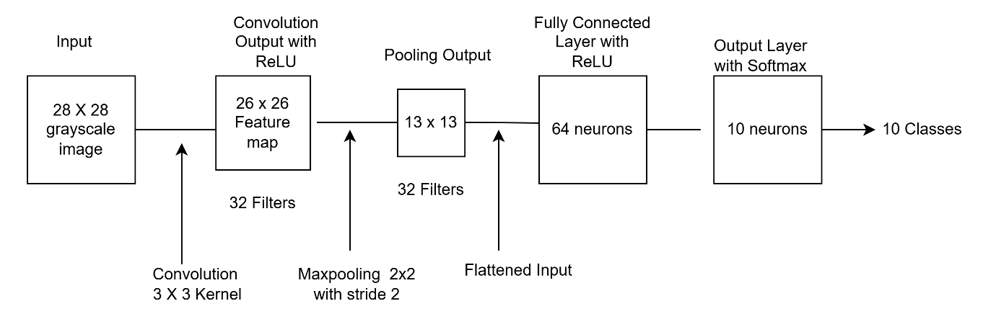
Architecture Diagram of Baseline CNN Model
The baseline Convolutional Neural Network (CNN) serves as a simple yet effective architecture for digit classification on the MNIST dataset. In this architecture, the convolutional layer acts as a feature extractor, identifying important spatial patterns from the input images, while the fully connected dense layer serve as a feature classifier, combining these extracted features to predict the correct digit class.
The model takes grayscale images of size 28×28×1 as input. The convolutional layer applies 32 filters of size 3×3 with stride 1, producing an output of 26×26×32 feature maps. A ReLU activation function introduces non-linearity, allowing the network to learn more complex patterns. Following this, a 2×2 max-pooling layer with stride 2 reduces the spatial dimensions to 13×13×32, lowering computational complexity while retaining important features.
The resulting feature maps are then flattened into a one-dimensional vector which serves as the input to the fully connected layer. This dense layer with 64 neurons and ReLU activation further processes these features. Finally, the output layer consists of 10 neurons, one for each digit class (0–9), with a softmax activation function that converts the outputs into class probability distributions.
Overall, the baseline CNN represents a foundational model for image classification tasks. Its relatively shallow structure makes it faster to train and less prone to overfitting on smaller datasets. However, with only one convolutional block, it is limited in its ability to capture higher-level features compared to deeper architectures such as the improved CNN.

Model Architecture
Component | Description
Input Layer | 28 x 28 x 1
Convolution Layer | 1 Conv2D layer, 32 filters of size 3×3, stride 1, ReLU activation
Pooling Layer | MaxPooling2D, 2×2, stride 2
Flatten Layer | Converts 13 × 13 × 32 pooled feature maps to 1D vector of size 5,408
Fully Connected Layers | Dense layer, 64 neurons, ReLU activation
Output Layer | Dense layer (10 neurons, Softmax)

Hyperparameters
Hyperparameter | Value
Optimiser | Adam
Learning Rate | 0.001 (default)
Loss Function | Categorical Crossentropy
Epochs | 15
Batch Size | 32
Validation_size | 0.1

Total Trainable Parameters
Convolutional Layer
- Input shape: 28×28×1 (grayscale image).
- Filters: 32
- Kernel size: 3×3
- Formula for parameters = (kernel height × kernel width × input channels) × number of filters + biases
- 3×3×1)×32+32=288+32=320
Dense Layer (Fully Connected, 64 neurons)
Input size to this layer depends on the output of Convolution and Pooling layers.
Step 1: Output of Conv layer
- Input = 28×28×1
- Kernel = 3, stride = 1, padding = "valid"
- Output size = (28−3+1)×(28−3+1)×32=26×26×32
Step 2: After MaxPooling (2×2)
- Output size = 13×13×32 = 5,408
- So, the Dense layer input = 5,408
- Formula = (5,408×64)+64=346,112+64=346,176
Trainable parameters = 346,176
Output Layer (10 neurons, Softmax)
- Input = 64
- Formula = (64×10)+10=640+10=650

Total Trainable Parameters = 320+346,176+650=347,146

4.1.1 Training and Testing Results
The plots of training/validation accuracy and loss, along with the test accuracy and loss results, are presented below.
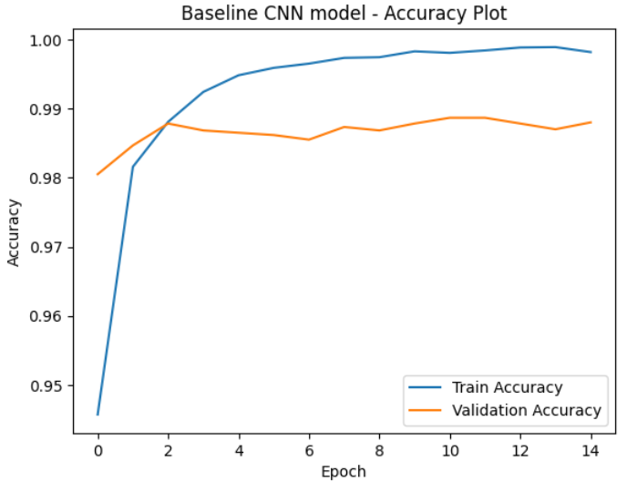
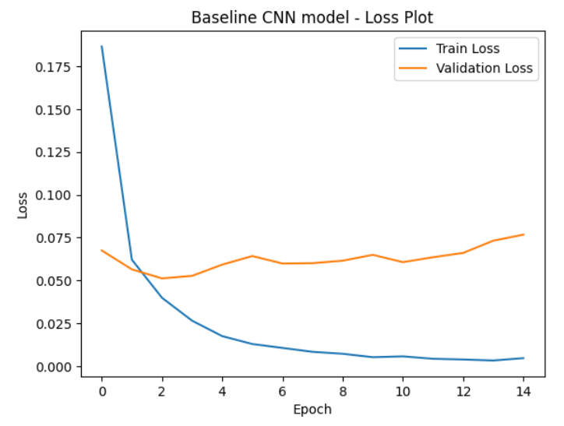
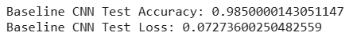
The baseline CNN showed superior performance on the MNIST dataset compared to the MLP models. Training accuracy increased quickly, reaching over 99% by the fourth epoch, while training loss dropped steadily to 0.039 by the final epoch. Validation accuracy remained stable at around 98.0–98.8%, with minor fluctuations in validation loss, showing good generalization and minimal overfitting.
On the test set, the model achieved 98.50% accuracy and a loss of 0.0727, confirming strong performance on unseen data. Overall, the baseline CNN is efficient, accurate, and effective for digit recognition, though its shallow depth limits feature learning compared to deeper models.

4.2 Improved CNN – Design and Architecture
The improved Convolutional Neural Network (CNN) is designed to enhance feature extraction and classification performance on the MNIST dataset by incorporating additional convolutional blocks, normalization, and regularization. Compared to the baseline model, this architecture increases depth and introduces techniques to stabilize training and prevent overfitting.
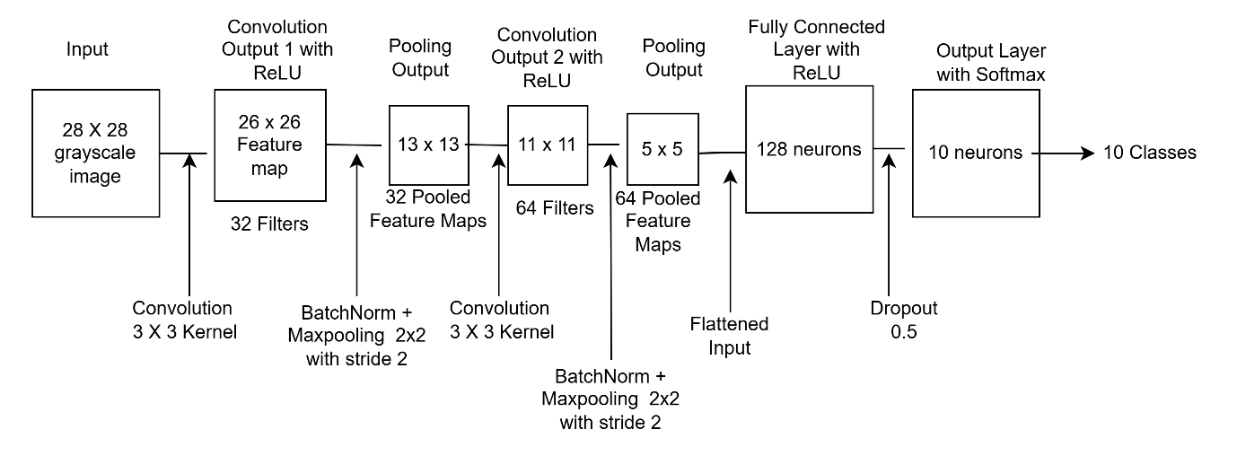
Architecture Diagram of Improved CNN Model
The input layer accepts grayscale images of size 28×28X1. The first convolutional block applies 32 filters of size 3×3 with stride 1 producing an output of 26 x 26 x 32. A ReLU activation function introduces non-linearity, and batch normalization is applied to stabilize activations and improve training efficiency. A 2×2 max-pooling layer with stride 2 then reduces the spatial dimensions to 13×13×32, retaining key spatial features while reducing computational cost.

The second convolutional block follows a similar structure but increases the filters to 64 producing an output of shape 11 x 11 x 64. Again, a 3×3 convolution with ReLU activation is used, followed by batch normalization, and a 2×2 max-pooling layer to further down sample the feature maps to 5 x 5 x 64. At this stage, the image representation is significantly compressed while retaining rich feature hierarchies that are useful for multiclass classification.

After the convolutional stages, the feature maps are flattened into a one-dimensional vector of 1600, enabling their use in fully connected layers. A dense layer with 128 neurons and ReLU activation is then introduced to combine the learned features into higher-level representations. To prevent overfitting, a dropout layer with a rate of 0.5 randomly deactivates half of the neurons during training, encouraging the network to learn more robust and generalized patterns. Finally, the output layer consists of ten neurons, each corresponding to one of the target classes, with a softmax activation function that converts the logits/raw outputs into class probabilities.

Overall, the improved CNN design balances depth, feature richness, and regularization by combining convolution, batch normalization, pooling, dense layers, and dropout.

Model Architecture
Component | Description
Input Layer | 28 x 28 x 1
Convolution Layers | 2 Conv2D layers  - Conv2D(32 filters of size 3×3, stride 1, ReLU activation)  - Conv2D(64 filters of size 3×3, stride 1, ReLU activation)
Batch Normalisation | Applied after each Conv2D layer
Pooling Layers | 2 MaxPooling2D layers, 2×2, stride 2
Flatten Layer | Converts 5x5x64 pooled feature maps to 1D vector of size 1600
Fully Connected Layer | Dense layer, 128 neurons, ReLU activation
Output Layer | Dense (10 neurons, Softmax)

Hyperparameter
Hyperparameter | Value
Optimiser | Adam
Learning Rate | 0.001 (default)
Loss Function | Categorical Crossentropy
Epochs | 15
Batch Size | 128
Dropout rate | 0.5
Validation_size | 0.1

Total Trainable Parameters
First Convolutional Block
- Kernel size = 3×3
- Filters = 32
- BatchNorm (32 channels) = 32×2=64
Parameters in the first convolutional block= (3×3×1) ×32+32+64=384
output size
- after convolution = 26 x 26 x 32
- after maxpool = 13 x 13 x32
Second Convolutional Block
- Input size = 13 x 13 x32
- Kernel size = 3×3
- Filters = 64
- BatchNorm (64 channels) =64×2=128
Parameters in the second convolutional block = (3×3×32)×64+64 + 128=18,624
Output size:
- After convolution = 11 x 11x 64
- after MaxPool = 5x5x64
Fully connected Layer (128 neurons)
- Input size after flattening = 5x5x64 =1600
Parameters = (1600 ×128) +128=204,928
Output Layer (10 neurons)
- Input = 128
Parameters = (128×10) +10=1,280+10=1,290

Total Trainable Parameters = 384+18,624+204,928+1,290=225,226

4.2.1 Training and Testing Results
The plots of training/validation accuracy and loss, along with the test accuracy and loss results, are presented below.
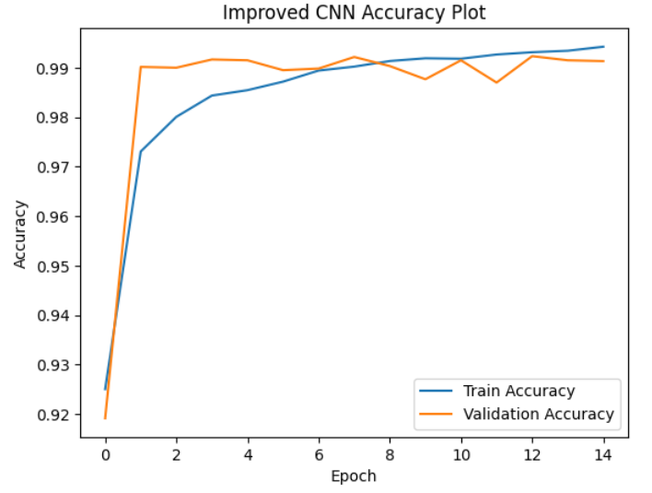
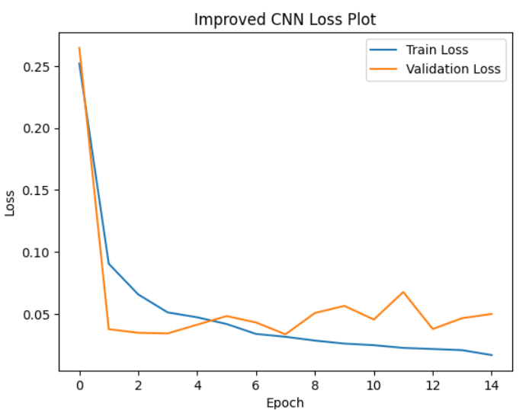
The improved CNN achieved strong performance on the MNIST dataset. The model was trained for 15 epochs and reached over 99.3% training accuracy with validation accuracy of 99%.
The final test accuracy was 99.18% with a test loss of 0.0293, indicating excellent generalization. Compared to the baseline CNN, the improved model demonstrated both higher accuracy and lower loss, particularly evident in early epochs where convergence was faster.
The introduction of a second convolutional block, batch normalization, and dropout enhanced the model’s ability to learn richer features while controlling overfitting. Although slight fluctuations in validation loss were observed in epochs 13–15, the model consistently maintained high accuracy above 99%, showing robustness.
Overall, the improved CNN architecture provided a significant performance boost over the baseline, confirming the effectiveness of deeper feature extraction and regularization techniques in digit classification tasks.

4.3 Results and Comparison of Baseline and Improved CNN models
The table below shows the test accuracy and loss of both the models.
Model | Epochs | Batch Size | Test Accuracy | Test Loss
Baseline CNN | 15 | 32 | 98.50% | 0.072
Improved CNN | 15 | 128 | 99.18% | 0.036

Below table shows the per class accuracy comparison between baseline and Improved CNN model
Class | Baseline CNN | Improved CNN
0 | 0.9949 | 0.9939
1 | 0.9938 | 0.9965
2 | 0.9806 | 0.9942
3 | 0.9911 | 0.9941
4 | 0.9908 | 0.9980
5 | 0.9832 | 0.9955
6 | 0.9791 | 0.9843
7 | 0.9883 | 0.9951
8 | 0.9733 | 0.9836
9 | 0.9732 | 0.9822

Analysis

The baseline CNN achieved a test accuracy of 98.50% with a loss of 0.072, while the improved CNN outperformed it with a test accuracy of 99.18% and a lower loss of 0.036.

Per-class accuracy results further highlight the improvements. The improved CNN consistently performed better across most digit classes, with the largest gains observed in more challenging digits such as 8 (from 97.3% to 98.4%) and 9 (from 97.3% to 98.2%). While both models performed exceptionally well, the improved CNN demonstrated greater robustness and generalization, making it the stronger architecture overall.

5. Evaluation of Learning rates and Optimiser Performance on Improved CNN Models (Task 3)
Experimented the improved CNN model with
- Same optimiser but two different learning rates - Adam optimiser with the learning rates 0.0005 and 0.01
- Different optimiser - SGD with momentum instead of Adam

5.1 Optimisation Using Different Learning Rates

The learning rate is a critical hyperparameter that determines the step size for weight updates during training. A learning rate that is too high can lead to unstable training and noisy convergence, whereas a learning rate that is too low slows down learning and may trap the model in suboptimal solutions. Selecting an appropriate learning rate balances convergence speed and stability, which is essential for achieving high performance in neural networks.

To investigate the effect of learning rate on the improved CNN model, two experiments were conducted using the Adam optimizer while keeping all other hyperparameters constant.

5.1.1 Experiment 1 – Adam with learning rate 0.0005
Hyperparameter | Value
Optimiser | Adam
Learning Rate | 0.0005
Epochs | 15
Batch Size | 128
Validation_size | 0.1

Execution Results
The plots of training/validation accuracy and loss, along with the test accuracy and loss results, are presented below.
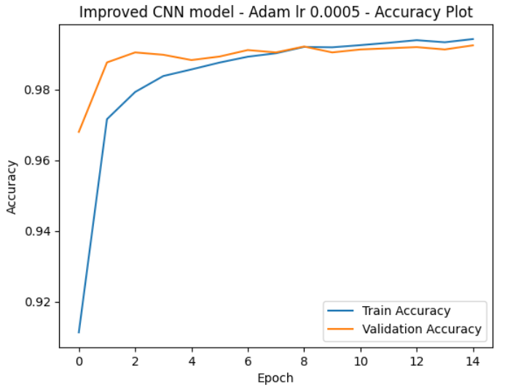
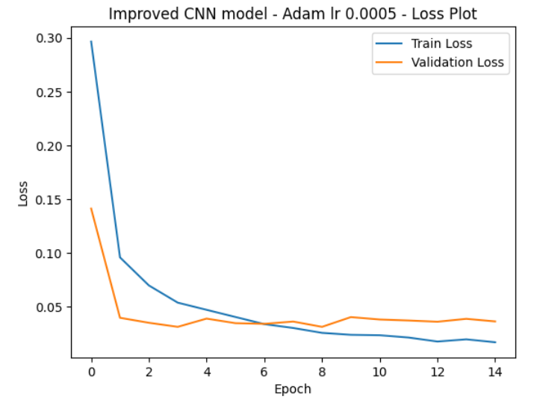
The smaller learning rate allowed stable, gradual weight updates, leading to high test accuracy and low loss

5.1.2 Experiment 2 – Adam with learning rate 0.01
Hyperparameter | Value
Optimiser | Adam
Learning Rate | 0.01
Epochs | 15
Batch Size | 128
Validation_size | 0.1

Execution Results
The plots of training/validation accuracy and loss, along with the test accuracy and loss results, are presented below.
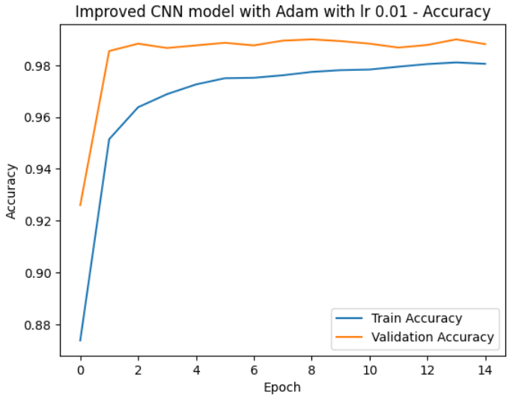
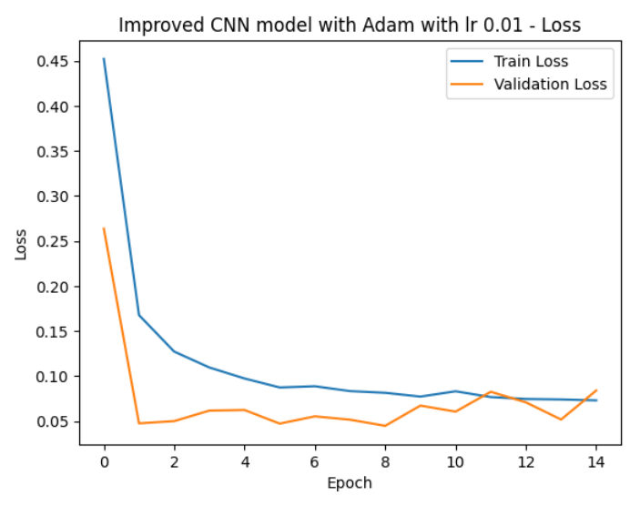

The higher learning rate led to faster but less stable weight updates, producing higher loss and noisier convergence.

5.1.3 Comparison of Test Results with different learning rates
Experiment No | Test Accuracy | Test Loss
1 | 99.28% | 0.0279
2 | 98.91% | 0.0633

The results clearly demonstrate that a smaller learning rate (0.0005) yields more stable training, smoother convergence, and better test accuracy and loss.

A larger learning rate (0.01) accelerates learning but introduces noisier updates, leading to minor fluctuations in the loss curve with reduced performance.

Overall, careful selection of the learning rate is critical for balancing stability, convergence speed, and final model performance in MLP and CNN training.

5.2 Optimisation Using Different Optimisers
In this section the performance of Adam and SGD with momentum optimisers are compared.

Adam Optimiser
Adam (Adaptive Moment Estimation) is widely used because it combines below two techniques:
- Momentum, which smooths learning by keeping track of past gradients, and
- RMSProp, which adjusts the learning rate for each weight individually.
This combination allows Adam to train faster and usually with less tuning than SGD.
However, the learning rate still matters:
- Too high can make training unstable.
- Too low makes training slow.
- A moderate value (like the default 0.001) often works well.

Stochastic Gradient Descent (SGD) Optimiser
SGD is one of the simplest optimisation methods. Instead of looking at the whole dataset, it updates weights using small batches.
Adding momentum improves SGD by reducing noise and making updates smoother.
- With a high learning rate, SGD may bounce around and fail to converge.
- With a low rate, it converges slowly.
- Momentum helps strike a balance by speeding up learning while keeping it stable.
Compared to Adam, SGD usually needs more careful tuning, but it often gives better generalisation in image recognition tasks.

5.2.1 Experiment 3 – SGD with learning rate 0.01
Hyperparameter | Value
Model | Improved CNN Model
Optimiser | SGD with Momentum 0.9
Learning Rate | 0.01
Epochs | 15
Batch Size | 128
Validation_size | 0.1

Execution Results
The plots of training/validation accuracy and loss, along with the test accuracy and loss results, are presented below.

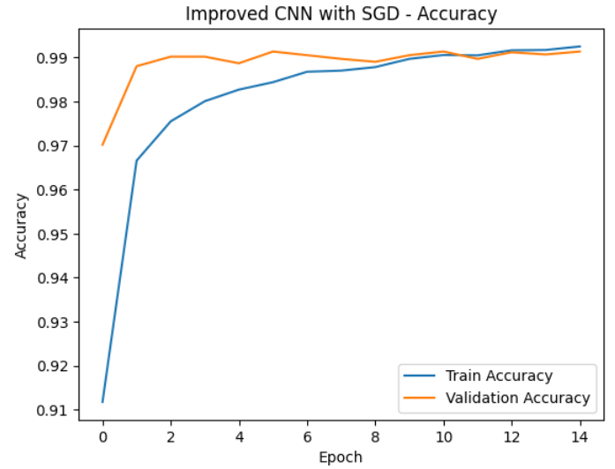
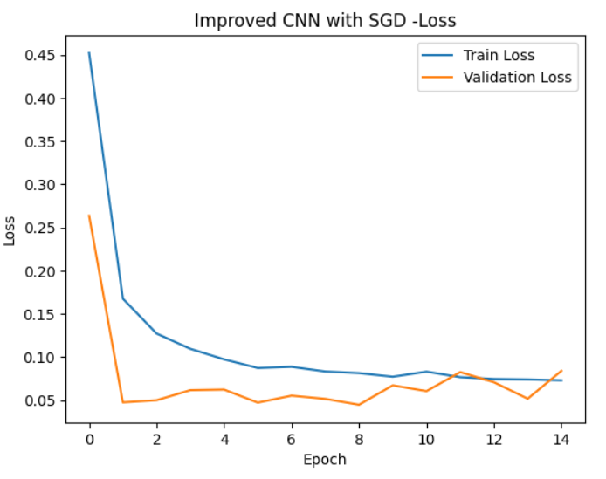
The results from this experiment are very similar to those obtained with Adam using a learning rate of 0.0005. Below table compares the results of both experiments.
Experiment No | Optimiser | Learning Rate | Test Accuracy | Test Loss
1 | Adam | 0.0005 | 99.28% | 0.0279
3 | SGD with momentum | 0.01 | 99.26% | 0.0259
Both optimisers produced nearly identical accuracy, with Adam slightly ahead (99.28% vs. 99.26%), while SGD with momentum achieved a marginally lower test loss. Adam benefits from adaptive learning rate adjustments, reducing the need for manual tuning, whereas SGD required momentum to stabilise training and reach competitive results. Overall, these findings show that careful tuning with either Adam or SGD can yield comparable performance, with small trade-offs between accuracy and loss.

6. Quality Comparison of the Tasks
Across all the three tasks, CNN models significantly outperformed MLPs, highlighting the importance of convolutional layers in image classification tasks. The improved CNN model achieved the highest accuracy, benefiting from deeper architecture and dropout regularisation. Among optimisers, Adam and SGD with momentum showed similar performance.

Ranking of Models (Best to Worst)
Rank | Model | Test Accuracy | Test Loss | Notes
1 | Improved CNN with Adam optimiser with lr 0.0005 | 99.28% | 0.0279 | Best result overall
2 | Improved CNN model with SGD with momentum (lr=0.01, momentum=0.9) | 99.26% | 0.0259 | Smooth convergence. Strong alternative to Adam with proper tuning
3 | Improved CNN model with Adam with lr 0.001 | 99.18% | 0.0364 | Performance slightly weaker than the above models
4 | Improved CNN model with Adam optimiser with lr 0.01 | 98.91% | 0.0633 | Too high learning rate with unstable updates and reduced generalisation.
5 | Baseline CNN Model | 98.50% | 0.0727 | Solid performance but limited by shallow design
6 | Improved MLP Model | 97.57% | 0.0913 | Better than baseline MLP model, but still weaker than CNN models
7 | Baseline MLP Model | 92.53% | 0.2656 | Lowest performance due to simple architecture and lack of feature extraction.

This ranking highlights how both architecture depth and optimisation strategy critically influence performance. CNNs consistently surpassed MLPs, and fine-tuning hyperparameters such as learning rate and momentum further refined accuracy and generalisation.

7. Conclusion
The Improved CNN with Batch Normalization and Dropout outperformed the Baseline CNN, achieving both higher accuracy and lower test loss. This shows that regularization techniques such as BatchNorm and Dropout play a key role in improving generalization.
Among the optimizers, Adam with a smaller learning rate of 0.0005 produced the best results, offering both stability during training and the highest accuracy overall. By contrast, Adam with a larger learning rate of 0.01 was aggressive, which reduced performance and caused instability.
SGD with momentum at a learning rate of 0.01 also performed strongly, with results close to Adam, demonstrating that when tuned carefully, SGD remains a competitive and reliable optimiser.
A key insight from these experiments is that tuning the learning rate has an impact on performance that is at least as significant as the choice of optimizer. With appropriate learning rates, both Adam and SGD achieved test accuracies above 99%. However, the best combination was the Improved CNN architecture with Adam at a learning rate of 0.0005, which achieved 99.28% accuracy with excellent generalization.

8. References
- Choulwar, A. (2019, April 12). The art of the convolutional neural network. Medium. https://medium.com/machine-learning-researcher/convlutional-neural-network-cnn-2fc4faa7bb63
- Baeldung. (2022, March 10). Training and validation loss in deep learning. Author. https://www.baeldung.com/cs/training-validation-loss-deep-learning#:~:text=At%20a%20point%2C%20the%20validation,usually%20known%20as%20early%20stopping
- Wager, S., Wang, S., & Liang, P. (2013). Dropout training as adaptive regularization. Proceedings of the 26th International Conference on Neural Information Processing Systems, 1, 351–359. https://dl.acm.org/doi/10.5555/2999611.2999651
- https://en.wikipedia.org/wiki/MNIST_database

